CS 255 System Design Document

UML Diagrams

UML Use Case Diagram
[In Module Six, you were asked to complete a use case diagram based on your system design. If you would like to make any adjustments to your diagram, please do so. Please insert your use case diagram here. Check to make sure that you included appropriate components and symbols and that your design meets the client’s needs.]
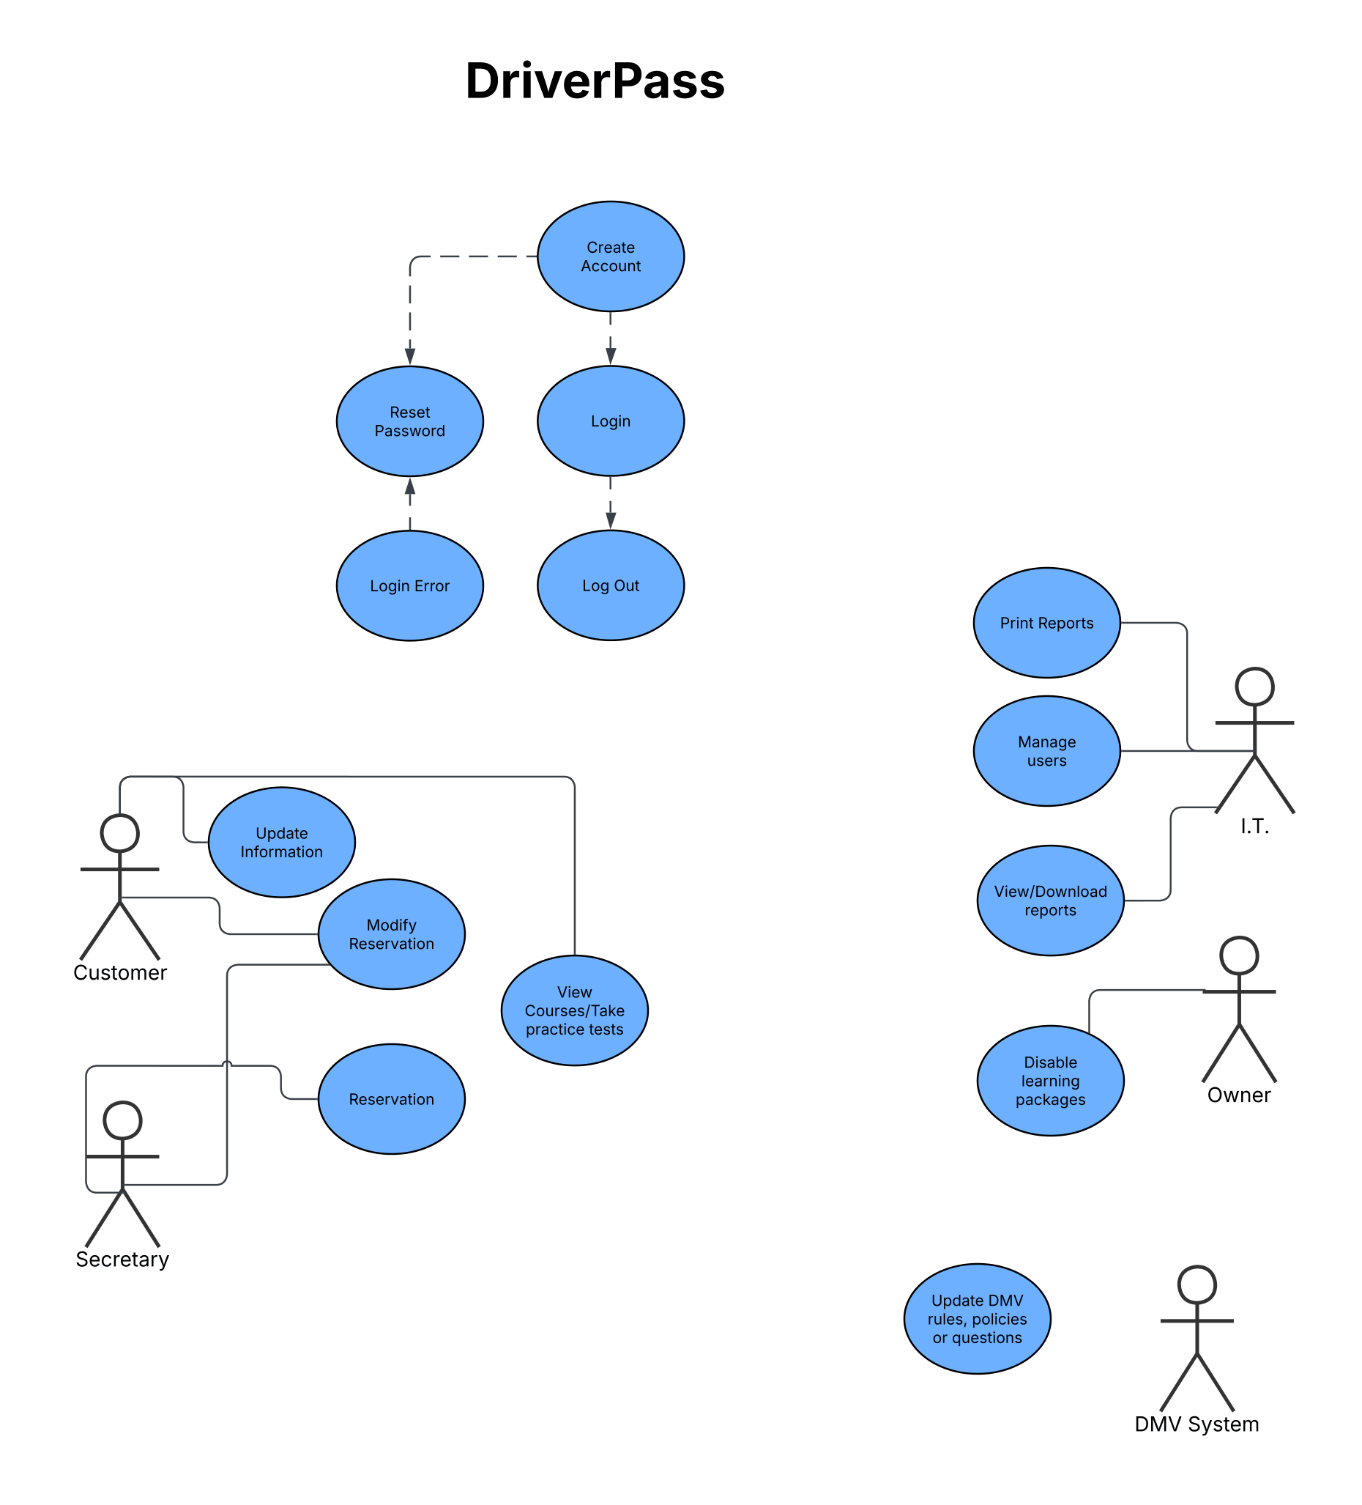

UML Activity Diagrams
[You were asked to choose two use cases and create two activity diagrams, one for each use case. Please insert both of your activity diagrams here. Check to make sure that you included appropriate components and symbols and that your design meets the client’s needs.]
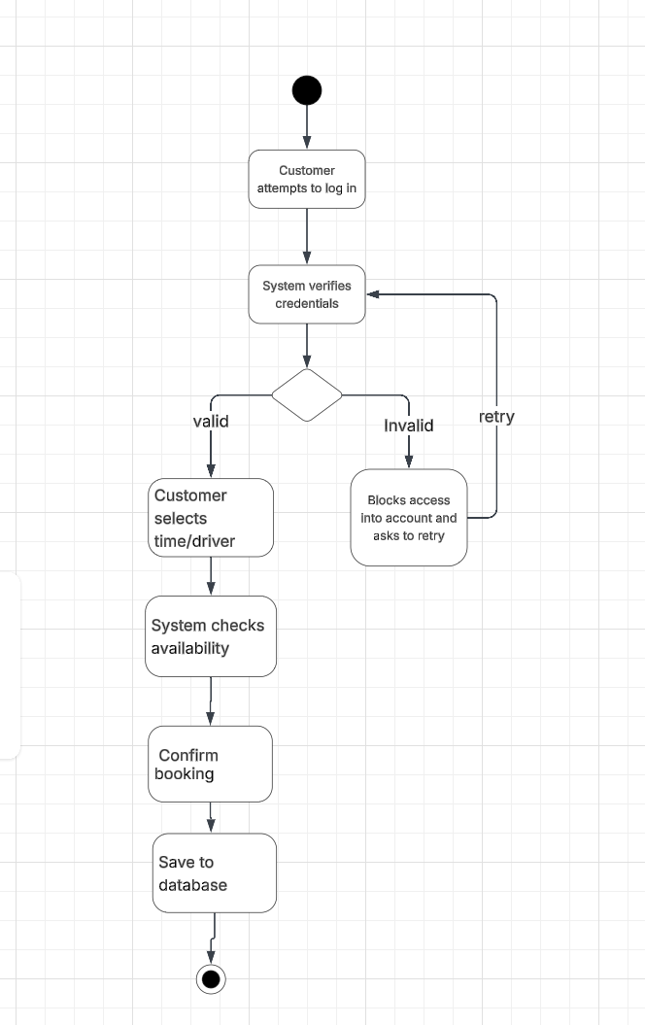

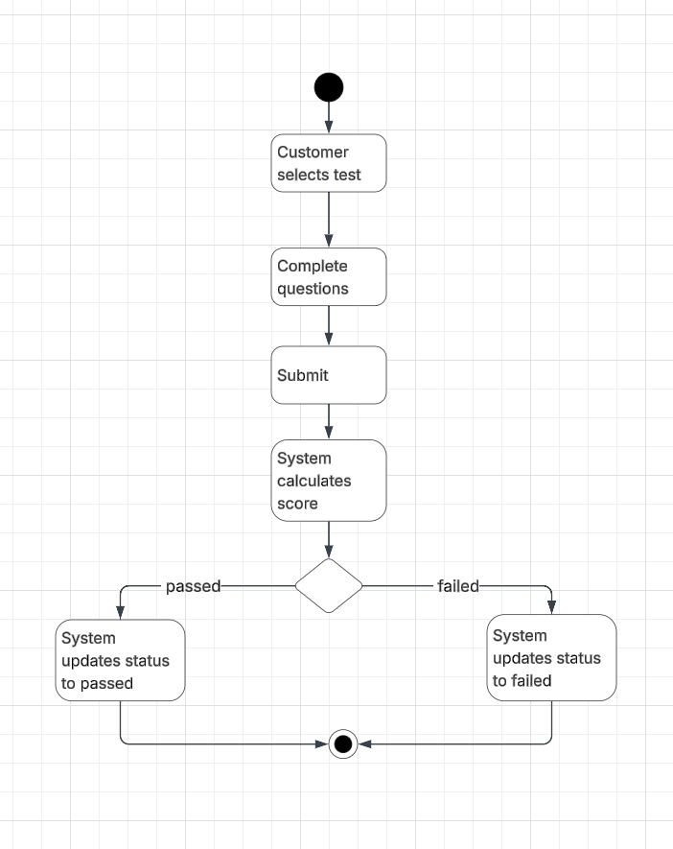

UML Sequence Diagram
[You were asked to create a sequence diagram based on one of the use cases you chose. Please insert your sequence diagram here. Check to make sure that you included appropriate components and symbols and that your design meets the client’s needs.]
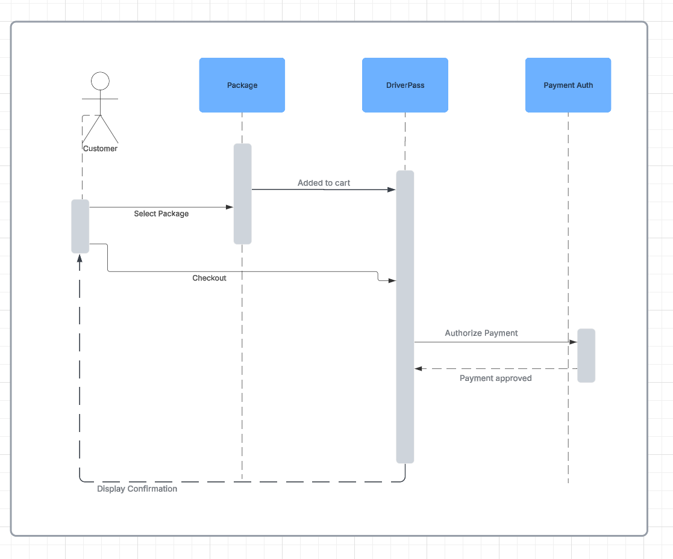

UML Class Diagram
[You were asked to create a class diagram based on the different classes and attributes needed for your system design. You are not required to include methods, but you may if you wish. Please insert your class diagram here. Check to make sure that you included appropriate components and symbols and that your design meets the client’s requirements.]
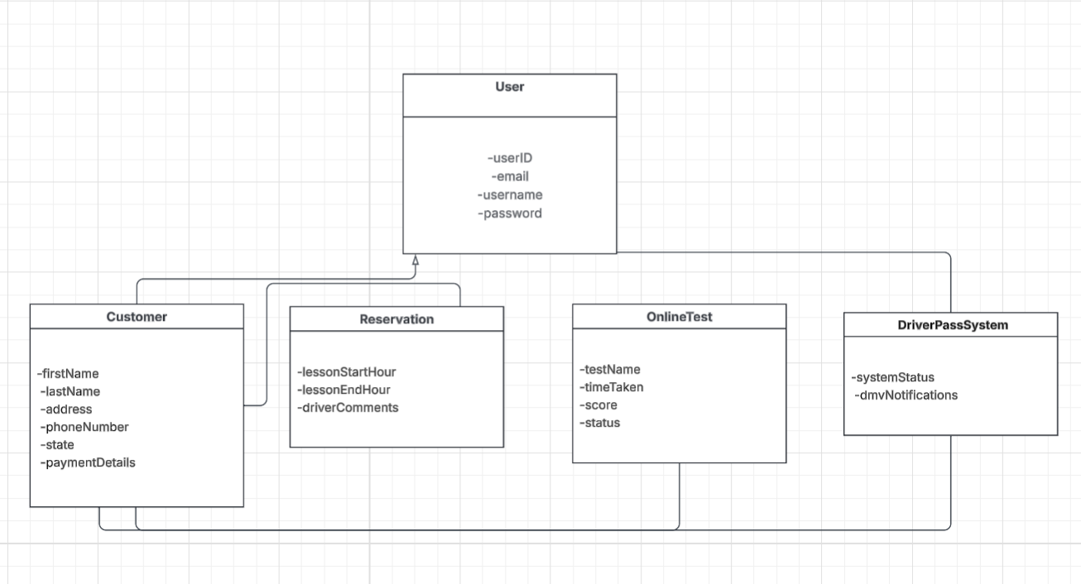

Technical Requirements
[Based on the diagrams you have created, describe the technical requirements of your system. These requirements should address the required hardware, software, tools, and infrastructure necessary for your system design.]

Infrastructure: The DriverPass system requires a cloud based back end infrastructure to automatically handle data backups, security, and server maintenance.
Hardware: The primary servers will be hosted through a third party cloud provider. End users require no specialized hardware and will access the system using standard computers or mobile devices with a reliable internet connection.
Software & Tools: The system must function as a web application. The database management system must be configured to accept data modifications while online to prevent redundancy across servers. Administrators will require spreadsheet software, such as Microsoft Excel, to download and view activity reports.
Integration: The system requires an active connection with the DMV to automatically receive notifications regarding updated rules, policies, and sample questions.

